SSH into linux EC2 instance from Linux machine

Link: https://www.youtube.com/watch?v=8UqtMcX_kg0

1. Create an EC2 instance using console

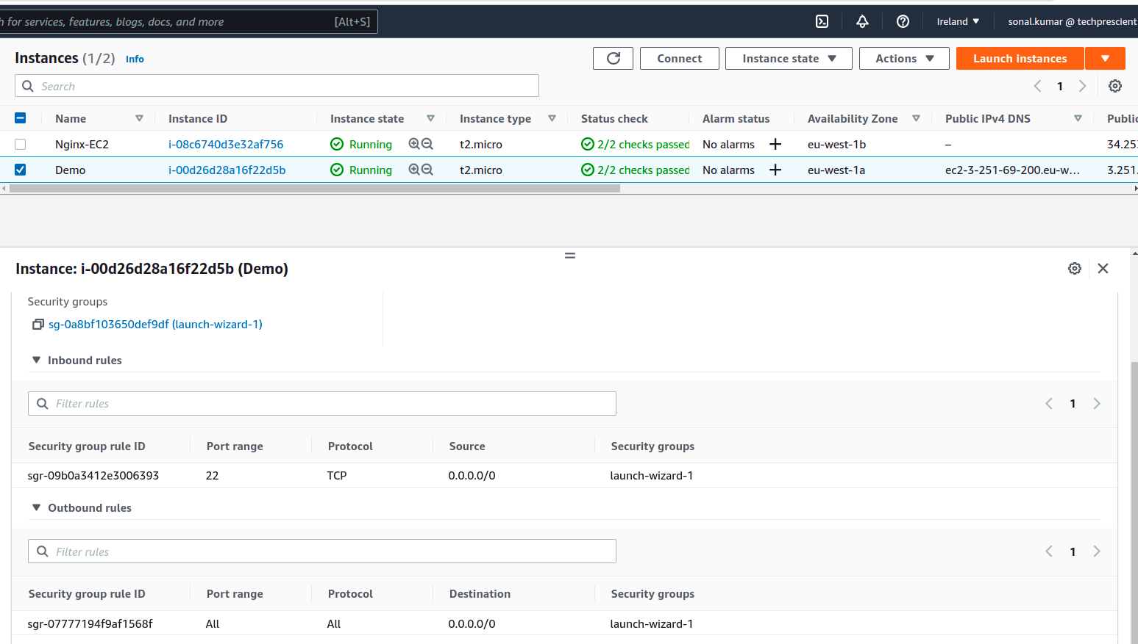
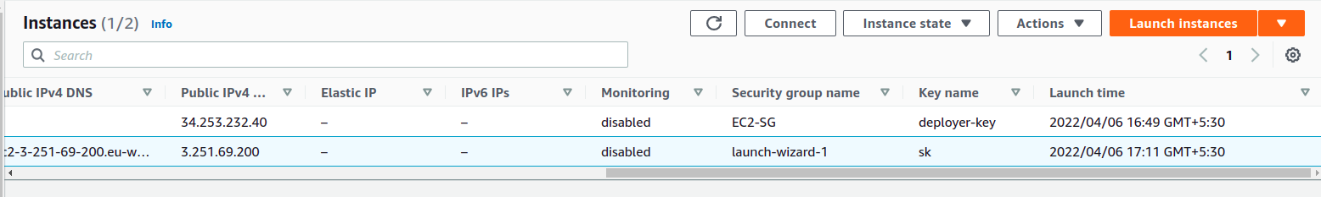

2. go to folder where .pem file is downloaded (which was downloaded during EC2 creation)
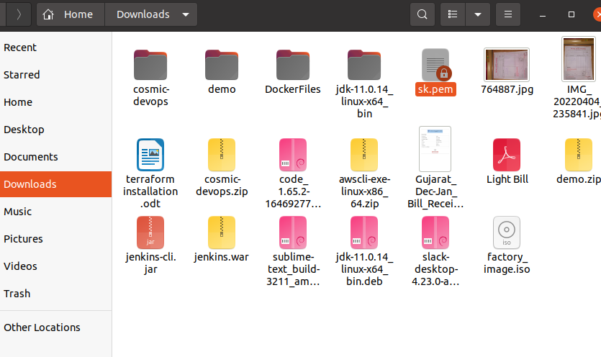
open terminal here
then run command : ssh -i "sk.pem" ec2-user@ec2-3-251-69-200.eu-west-1.compute.amazonaws.com

on terminal

pass ‘yes’ when asked

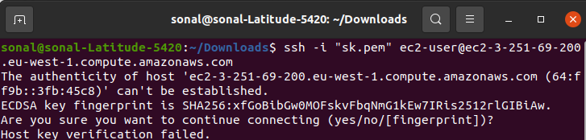

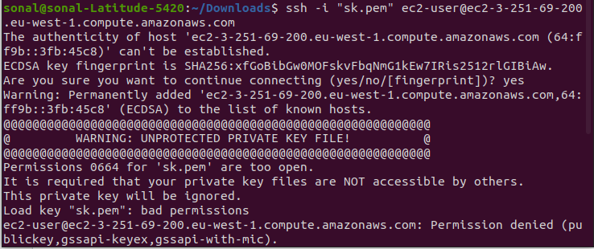

Permission denied for this use command: chmod 400 sk.pem
Then run tha above command again : ssh -i "sk.pem" ec2-user@ec2-3-251-69-200.eu-west-1.compute.amazonaws.com

